**Project Design Phase**

**Solution Architecture**

|  |  |
| --- | --- |
| Date | 28 June 2025 |
| Team ID | LTVIP2025TMID59203 |
| Project Name | EDUCATIONAL ORGANISATION USING SERVICENOW |
| Maximum Marks |  |

**Solution Architecture:**

Solution architecture is a complex process – with many sub-processes – that bridges the gap between **educational challenges** and **technological solutions in academic environments**.

Its goals are to:  
• Find the best tech solution to solve existing **institutional and learning-related problems**.  
• Describe the structure, characteristics, behavior, and other aspects of the **educational software or platform** to project stakeholders (e.g., administrators, faculty, students).  
• Define features, development phases, and solution requirements specific to the needs of educational institutions, such as student management, course delivery, and performance tracking.  
• Provide specifications according to which the solution is defined, managed, and delivered within the context of an academic ecosystem.

**Example - Solution Architecture Diagram:**

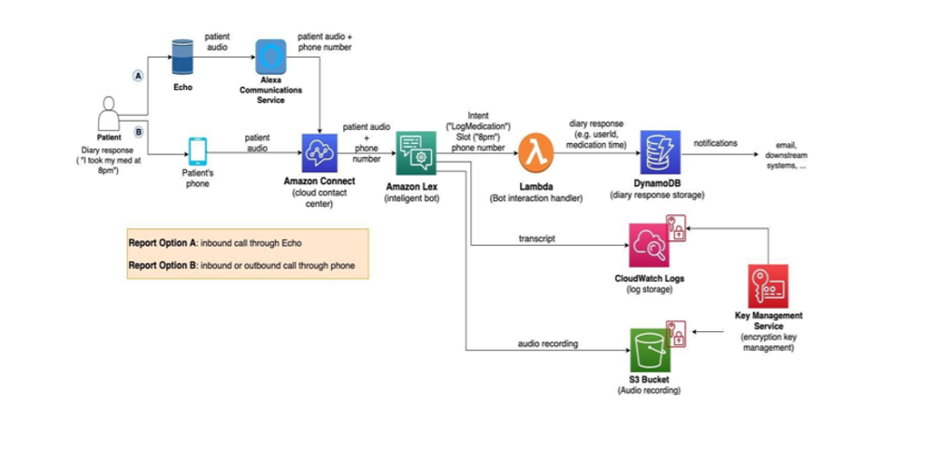

Figure 1: Architecture and Data Flow of the Educational Organization Management Platform